**Case Study Report: Exploring Field Test Mode on iPhone**

**Objective:** This case study aims to explore and understand key networking information available on smartphones by using the Field Test Mode. As a student using an iPhone 11, I followed the guidelines to gather technical details about my phone's network settings and performance.

**1. Device Information:**

* **Device Type:** iPhone 11
* **Operating System:** iOS

**2. Key Network Parameters and Their Importance:**

* **PLMN (Public Land Mobile Network):**The PLMN 404 94 indicates that the network is part of a particular service provider, identified by the Mobile Country Code (404) and Mobile Network Code (94).

**Importance:** Helps in determining the cellular network to which the phone is connected.

* **Band Info:**The current band info is 1, indicating the specific frequency band the device is using for communication.

**Importance:** Determines network bandwidth and affects speed and coverage.

* **Bandwidth:**The bandwidth is recorded as 5 MHz, indicating the frequency spectrum used by the network.

**Importance:** Determines how much data can be transmitted in a given period.

* **CellID:**The CellID 164483124 represents the specific tower that the phone is connected to.

**Importance:** Useful for identifying the current cell tower location and its coverage.

* **Radio Access:**The phone uses LTE (Long-Term Evolution) for communication.

**Importance:** LTE is known for high-speed data transmission and better coverage than earlier technologies.

* **PCI (Physical Cell ID):**PCI 401 is used by the device to uniquely identify the physical cell.

**Importance:** Helps with handover decisions and managing interference in cellular networks.

* **TAC (Tracking Area Code):**The TAC is listed as 55357, which represents the geographical area in which the phone is currently located.

**Importance:** Useful for tracking mobile location over time and managing mobility in a network.

* **EARFCN DL (E-UTRA Absolute Radio Frequency Channel Number - Downlink):**The EARFCN DL is 390, which identifies the downlink channel the phone uses to receive data.

**Importance:** Determines which frequency band is used for communication.

**3. Steps to Access Field Test Mode:**

1. Open the phone dialer and dial *3001#12345#* to access the Field Test Mode.
2. Navigate to the LTE section for relevant network details.
3. Took a screenshot of the technical details including PLMN, Band Info, and CellID.

**Details Collected:**

**PLMN: 404 94**

**Bandwidth: 5 MHz**

**CellID: 164483124**

**Radio Access: LTE**

**PCI: 401**

**TAC: 55357**

**EARFCN DL: 390**

**4. Screenshot:**

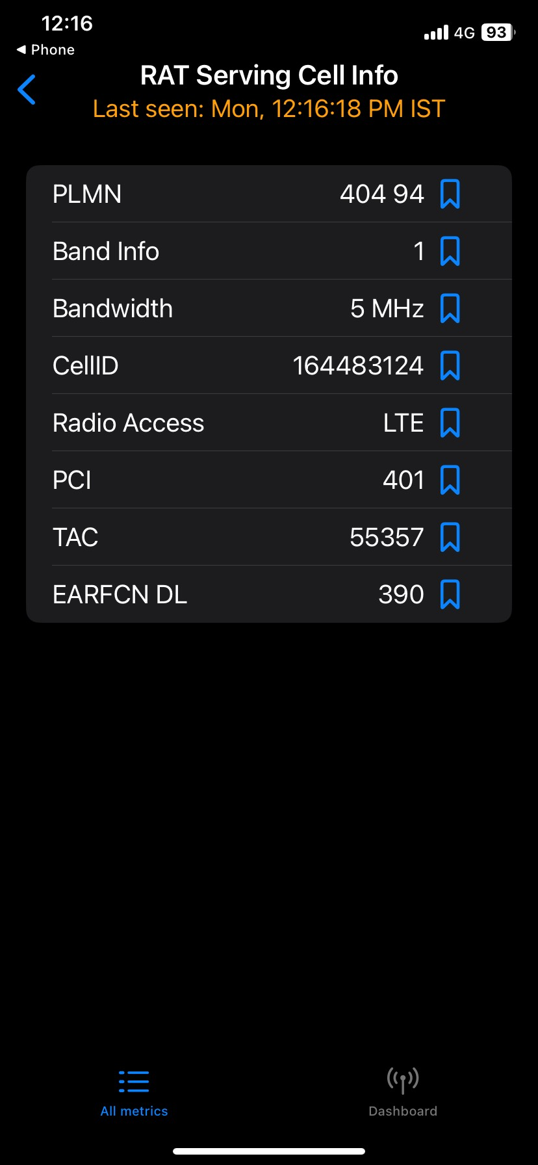

**5. Conclusion:**

By accessing Field Test Mode on my iPhone, I was able to gather critical networking details. This process has enhanced my understanding of mobile network performance and the significance of parameters like PLMN, CellID, and signal bandwidth in ensuring seamless communication.

The network performance on my device was satisfactory, with stable LTE connectivity and moderate signal coverage. These findings emphasize the importance of understanding network diagnostics to optimize device performance and maintain reliable connectivity.

**Submission Details:**

∙ The report and screenshots have been uploaded to a private GitHub repository. The GitHub repository link was submitted via Google Classroom as required.

**References:**

1. Waveform Guide: Field Test Mode

2. Signal Booster Guide: Field Test Mode

Name: Amrish S

Register No.: RA2211003050113

III CSE B

Github Link: https://github.com/AmrishS14/CN-Case-Study